**USECASES**

**Use Case**: Rule Selection

**Level**: High

**Description**: Various rules are coded like Rule 90, 50, 94,126. Specific rule method is called through the CAGenerationSet class. Rule selection depends upon users selection in the combo box.

**Pre-Condition**: Generate CAGeneration row and set the center value of CAGeneration array.

**Actor**: User

**Standard** Flow:

CAGeneration class has an array of CACell class ->Assign ‘Black color’ to the center value and ‘White color’ to other values in CAGeneration Array-> CAGenerationSet contains array of CAGeneration and print the values of the selected Rule from CARule class through rules() method.

**Use** **Case**: Start the cell Generation

**Level**: Medium

**Description**: Generate array of CAGeneration based on the rule selected by user.

**Pre-Condition**: Specify the number of rows to be generated.

**Actor**: User

**Standard** **Flow**:

Click Start button -> CAGeneration class contains an array of CACell class ->Assign ‘Black color’ to the center value and ‘White Color’ to other values in array of CAGeneration -> CAGenerationSet contains array of CAGeneration and print the values as per the rule selected from CARule class through rules() method. Rule generation method generates the value of next row by looking up the values in previous row.

**Use** **Case**: Stop the cell generation.

**Level**: Medium

**Description**: Stop the generation and displaying further rows and exit the execution.

**Pre-Condition**: Cell Generation should have been started.

**Actor**: User

**Standard** **Flow**:

Click Start button -> CAGeneration class contains an array of CACell class ->Assign ‘Black color’ to the center value and ‘White color’ to other values in array of CAGeneration -> CAGenerationSet contains array of CAGeneration and print the values as per the rule selected from CARule class through rules() method. -> Click on Stop button to stop and exit the execution mid way.

**Note**: Rule generation method generates the value of next row by looking up values in previous row.

**Activity** **Diagram**:

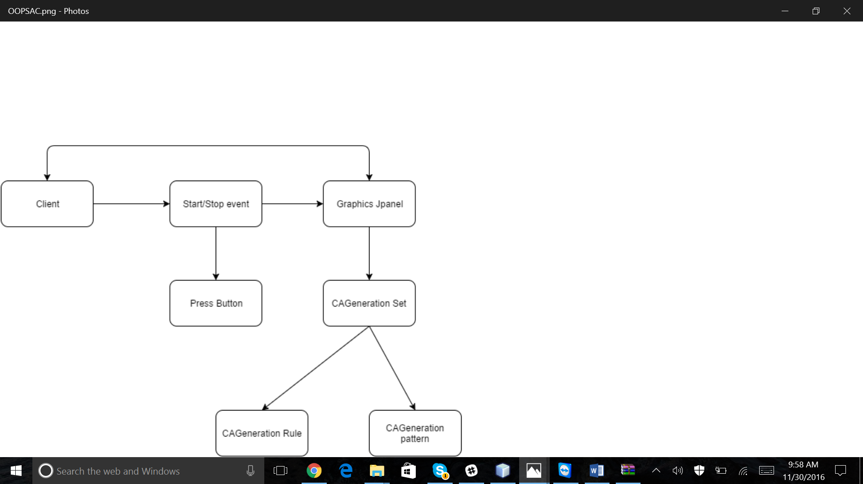

Use Cases:

